Pages 90 – 99 ***Java Programming A Comprehensive Introduction***

**Section 1: Define / Answer**

Explain the difference between a **for** loop and a **while loop**-

For has initializer while while loop doesn’t have it

What is the basic difference between a **do-while** loop and [**or/while]** loops?

Do while would run the problem before the comparison while the while loop would run the comparison before looping

How do **break** statements work in relation to **for, while,** and **do-while** loops?

**Break would stop the loop**

Describe how an infinite **for** loop operates.

Once it operate, it would keep looping without stop

**Programming Assignments**

**1st Task: Pg. 115 #15** Java Programming *A Comprehensive Guide*

There are 6 different programs + output required for this assignment.

Please Have 6 Different snipping photos with programs and outputs.

Hint** The programs should not be very long for each answer.

The Class **ContDemo** in Chapter 3 shows one way to use a **for** loop to **print the even numbers 0 to 100.** Write programs that print the same output as that program, but do it in the following ways:

1. Using a **for** loop that increments the loop control variable by 2 each iteration

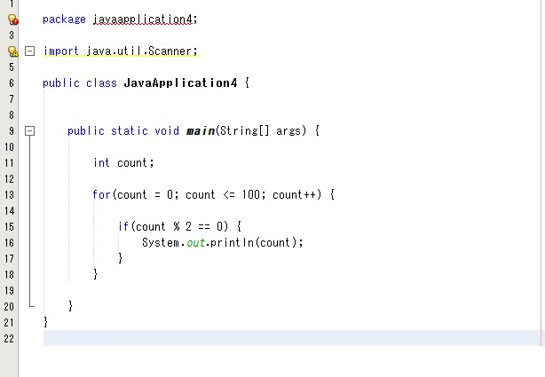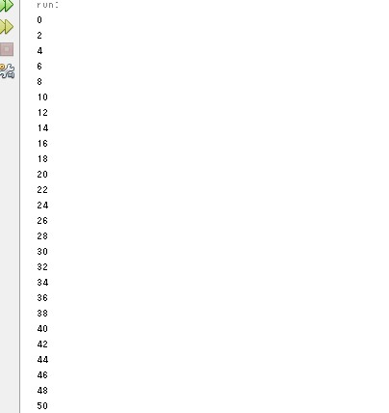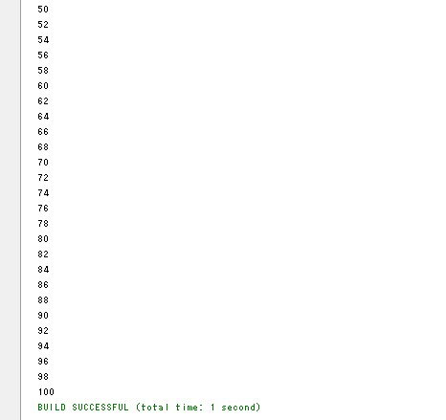

1. Using a **for** loop whose loop control variable goes from 0 to 50.

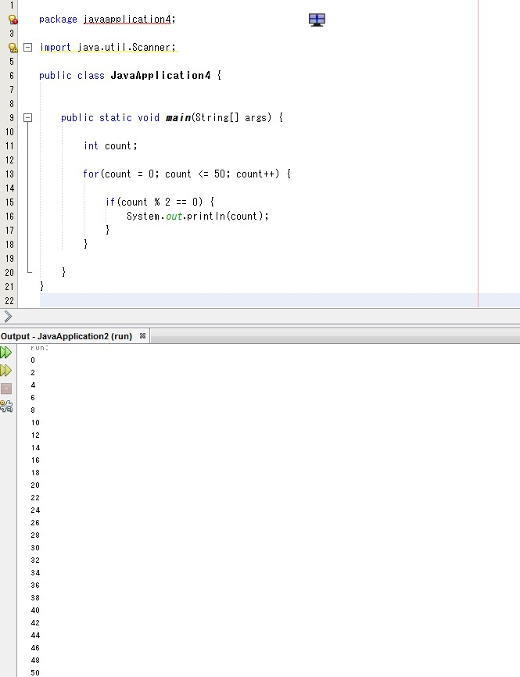

1. Using a **for** loop whose loop control variable goes from 100 down to 0.

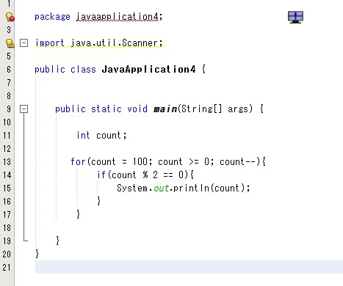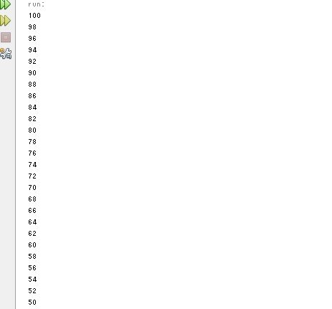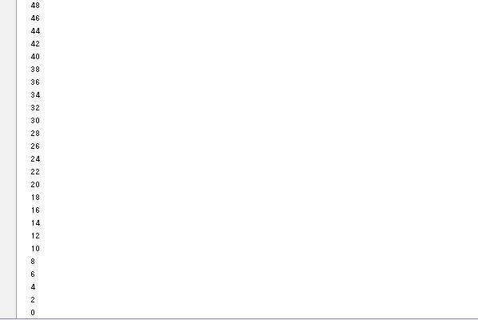

1. Using an infinite **for** loop with no conditional expression and exiting the loop with a **break** statement.

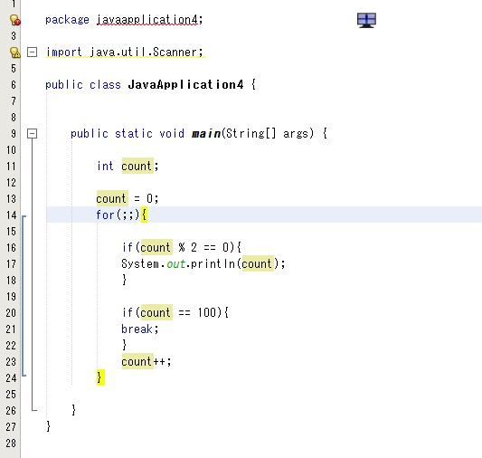

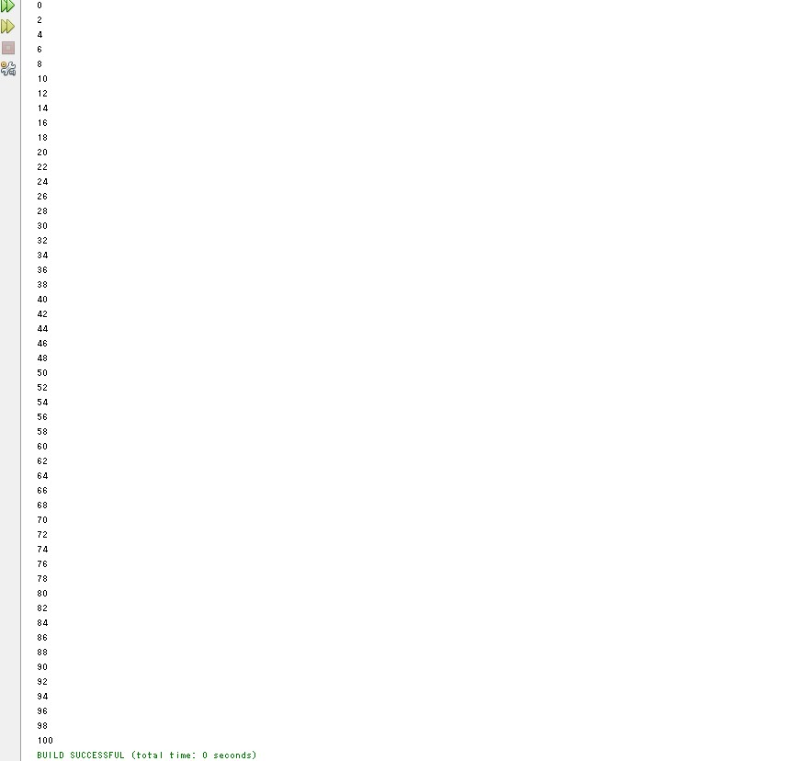

1. Using a **while** loop.

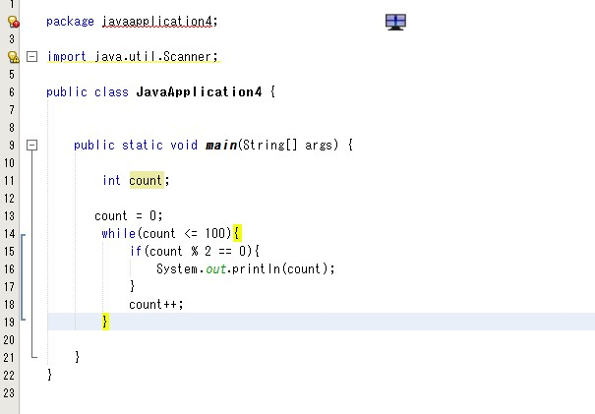

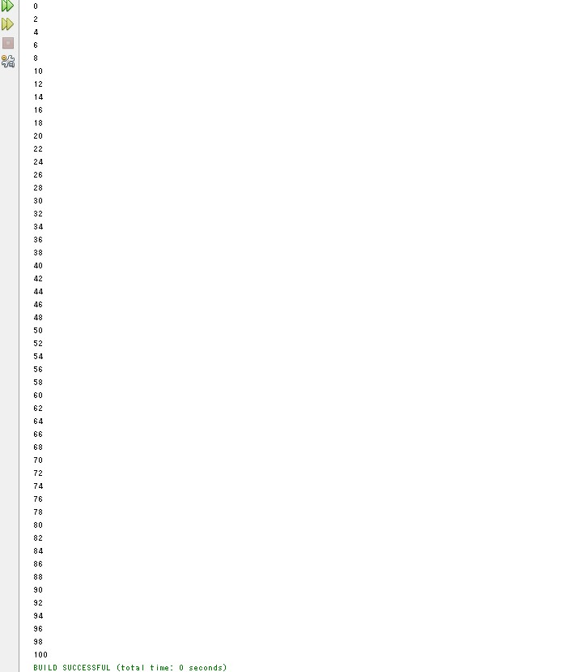

1. Using a **do-while** loop.

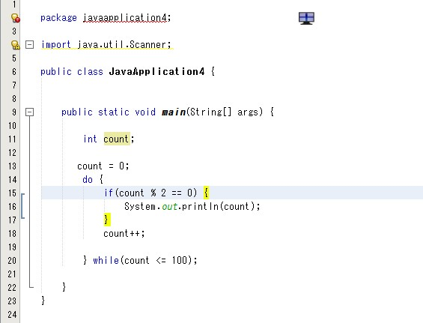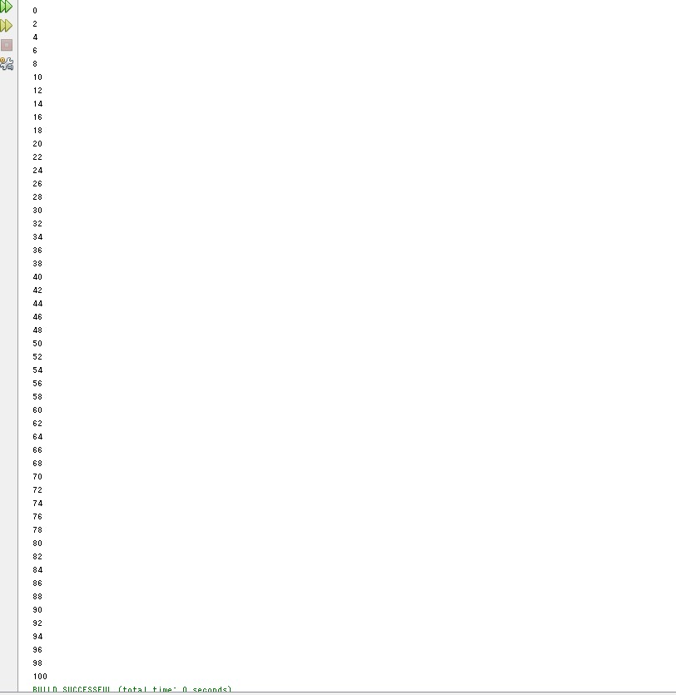

There should be 6 different Snipping photos. One photo for each program A – F.

**2nd Task-** Change Calculator

Write a program that directs a cashier how to give change. The program has two inputs: The amount due and the amount received from the customer. Display the dollars, quarters, dimes, nickels, and pennies that the customer should receive.

